MANGOCHI CATHOLIC DIOCESE MOCK EXAMINATIONS
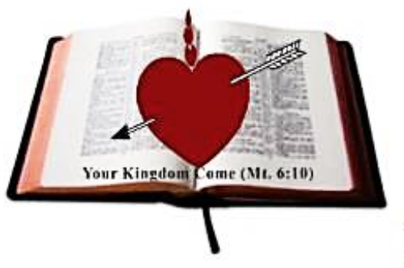
2025 MALAWI SCHOOL CERTIFICATE OF EDUCATION
BIOLOGY
SUBJECT NUMBER: M 022/I
Tuesday, 13 May 2025 Time Allowed: 2 hrs
8:00 - 10:00 am
PAPER I
100 Marks

Instructions
Question number | Tick if answered | Do not write in these columns
1
2
3
4
5
6
7
8
9
10
11
12
13
14
 | Total
- This paper contains 11 printed pages. Please check.
- Before you begin, write your Examination Number at the top of each page of the question paper.
- This paper has two sections, A and B. section A has 10 questions and Section B has three questions.
- Answer all the 13 questions in the spaces provided. The maximum number of marks for each answer is indicated against each question.
- In the table provided on this page, tick against the question number you have answered.
- At the end of the examination, hand in your paper to the invigilator when time is called to stop writing.

© 2025 MH DIOCESE Turn Over
SECTION A (70 marks)

Answer all the questions in this section in the spaces provided.
- a.
- State the effect of high auxin concentration in a root tip
_________________________________________________________ (1 mark)
- Explain any one application of auxin in everyday life.
______________________________________________________________________________________________________________________________ (2 marks)
- Explain the effect of water intake on urine production.
_______________________________________________________________________________________________________________________________ (2 marks)
- Describe any one evidence of evolution.
_______________________________________________________________________________________________________________________________ (2 marks)
- a. Explain any one adaptation of bird’s skeleton to its function.
_____________________________________________________________________________________________________________________________________________ (2 marks)
- Figure 1 is a flow diagram showing the types of white blood cells

White blood cell

Phagocytes lymphocytes

B- Lymphocytes T-Lymphocytes

P Neutrophils
R Killer memory

Figure 1 Antitoxins agglutinis Q
i. Identify blood cells Q and R
Q: ______________________________________________________________
R: ______________________________________________________ (2 marks)

Continued/…
ii. Explain the role in body defense played by blood cells Q
_____________________________________________________________________
___________________________________________________________ (2 marks)
iii. In the space provided, draw a cross- section of blood cell P and label any two parts.

(3 marks)
- a. State any two ways of mitigating climate change in an ecosystem.
_____________________________________________________________________________________________________________________________________________ (2 marks)
b. Figure 2 is a diagram showing a process during reproduction 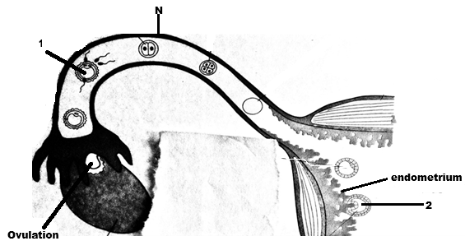
Figure 2

Continued/…

- Identify the part labelled N
N: _______________________________________________________ (1 mark)

- Explain any one adaptation of the part labelled N to its function.
___________________________________________________________________________________________________________________________ (2 marks)
- Identify the process taking place at 1 and 2
1:____________________________________________________________
2:___________________________________________________ (2 marks)
- Name the hormone that helps the process at number 2 to occur.
_______________________________________________________ (1 mark)

- a. A scientist crossed pure-line of peas with white flowers and pure-line of peas with red flowers. The offspring were neither white nor red flowered peas, but pink.
(i). State the Mendelian Principles of genetics observed in the experiment
____________________________________________________________________________________________________________________________ (1 mark)
(ii). Give one reason why Mendel used peas in his experiments
____________________________________________________________________________________________________________________________ (1 mark)

- The length of the index finger of 40 students in a class were recorded in table below
Length of index finger | Number of students
65mm | 5
68mm | 8
71mm | 4
76mm | 5
77mm | 6
78mm | 5
80mm | 7
82mm | 2
Table 1
Continued/…
- What type of variation is shown in the table?
_______________________________________________________ (1 mark)
- Find the mode for the length of the index finger.
_______________________________________________________ (1 mark)
- i. State any two causes of variation among organisms of the same specie.
________________________________________________________________________________________________________________________________ (2 marks)

- What is the importance of variation to organisms of the same specie?
__________________________________________________________ (1 mark)
- a. Explain any two adaptations of hydrophytes to their habitats.
______________________________________________________________________________________________________________________________________________________________________________________________________________________________________________________________________________________________________________________________________________________________ (4 marks)
- Describe how the following factors affect plant productivity in an ecosystem.
- Topography____________________________________________(1 mark)
- Soil __________________________________________________(1 mark)
- a. Figure 3 is a diagram showing a villus in the walls of the small intestine
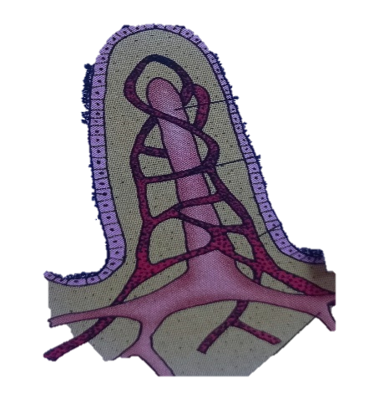
W
X

Y

- Identify the parts labelled W and Y.
W: ___________________________________________________________
Y: ___________________________________________________ (2 marks)

Continued/…
- State the function of the part labelled X.
_______________________________________________________ (1 mark)
- Name any one substance that is drained into the lymphatic vessel.
_______________________________________________________ (1mark)
- Describe any one abnormal condition associated with the human digestive system.
______________________________________________________________________________________________________________________________ (2 marks)
- Give one way of controlling constipation.
__________________________________________________________ (1 mark)
- a. Figure 4 is a diagram showing structure of a neuron.
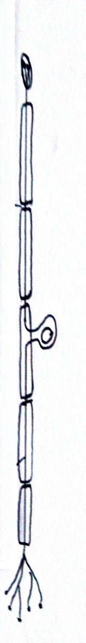
A B
Figure 4
- In the same diagram print an arrow to show direction of an impulse.
_____________________________________________________ (1 mark)
- Identify the part labelled B.
_____________________________________________________ (1 mark)
- Explain the adaptation to function of the part labelled A.
_________________________________________________________________________________________________________________________ (2 marks)
- . Figure 5 is the diagram of a neuron during action potential.
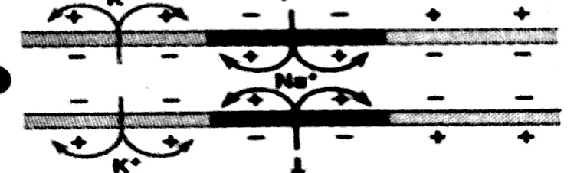

Figure 5
- In the same diagram, print the letter E to show the position of impulse transmission.
(1 mark)
Continued/…
- Give a reason to your answer to question 7b (i)
___________________________________________________________ (1 mark)
- Explain how adrenaline hormone prepares the body for fight.
_____________________________________________________________________________________________________________________________________ (2 marks)
- Figure 6 is a graph showing the concentration of antibodies in the plasma of a person over a certain period of time.
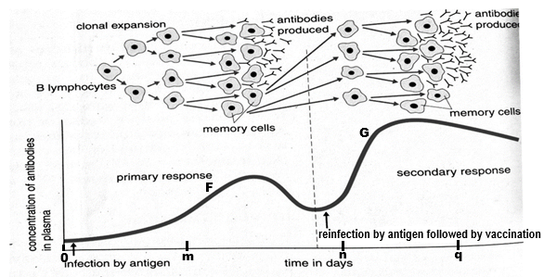 Figure 6

- What type of immunity is shown at F and G?
F: ____________________________________________________________
G: __________________________________________________ (2 marks)

- Explain why the concentration of antibodies in the plasma increased after m days.
__________________________________________________________________________________________________________________________________ (2 marks)
- State the relationship between vaccination and infection in terms of antibody response.
__________________________________________________________________________________________________________________________________ (1mark)

Continued/…
- Figure 7 is a diagram showing two types of respiration in the form of equations H and I.
H: Glucose + Oxygen Carbon dioxide + Water +2898KJ of energy
I: Glucose Lactic acid + 150KJ of energy
Figure 7
- i. Which tissue respiration occurs in the cytoplasm
________________________________________________________________________________________________________________________________________ (1 mark)

ii. Why is less energy produced in equation I than in equation H from the same amount of glucose?
_______________________________________________________________________________________________________________________________________________________________________________________________________________ (2 marks)
- Explain any one importance of gaseous exchange.
_______________________________________________________________________________________________________________________________________ (2 marks)
- a. A person had a painless sore on the open part of the genital organ and skin rash on the palm.
- Name the disease that the person was suffering from.
___________________________________________________________ (1 mark)
- Name the causative agent of the disease named in a (i).
___________________________________________________________ (1 mark)
- Explain any one way of preventing the type of disease named in 10 a (i).
_______________________________________________________________________________________________________________________________________ (2 marks)

Continued/…
- State any one impact of the disease to an individual.
______________________________________________________________ (1 mark)
SECTION B (30 marks)
Answer all the three questions in this section in the spaces provided under each question. Your answers should be in an essay form.
- Describe any five functions of the human circulatory system.
________________________________________________________________________
________________________________________________________________________________________________________________________________________________________________________________________________________________________________________________________________________________________________________________________________________________________________________________________________________________________________________________________________________________________________________________________________________________________________________________________________________________________________________________________________________________________________________________________________________________________________________________________________________________________________________________________________________________________________________________________________________________________________________________________________________________________________________________________________________________________________________________________________________________________________________________________________________________________________________________________________________________________________________________________________________________________________________________________________________________________________________________________________________________________________________________________________________________________________________________________________________________________________________________________________________________________________________________________________________________________________________________________________________________________________________________________________________________________________________________________________________________________________________________________________________________________________________________________________________________________________________________________________________________________________________Continued/…
________________________________________________________________________________________________________________________________________________________________________________________________________________________________________________________________________________________________
(10 marks)
- Explain any five factors affecting the rate of transpiration in plants.
________________________________________________________________________________________________________________________________________________________________________________________________________________________________________________________________________________________________________________________________________________________________________________________________________________________________________________________________________________________________________________________________________________________________________________________________________________________________________________________________________________________________________________________________________________________________________________________________________________________________________________________________________________________________________________________________________________________________________________________________________________________________________________________________________________________________________________________________________________________________________________________________________________________________________________________________________________________________________________________________________________________________________________________________________________________________________________________________________________________________________________________________________________________________________________________________________________________________________________________________________________________________________________________________________________________________________________________________________________________________________________________________________________________________________________________________________________________________________________________________________________________________________________________________________________________________________________________________________________________________________________________________________________________________________________________________________________________________________________________________________________________________________________________________________________________________________________________________________ Continued/…
________________________________________________________________________________________________________________________________________________________________________________________________________________________________________________________________________________________________
(10 marks)
- Describe the process of insulin production.
________________________________________________________________________________________________________________________________________________________________________________________________________________________________________________________________________________________________________________________________________________________________________________________________________________________________________________________________________________________________________________________________________________________________________________________________________________________________________________________________________________________________________________________________________________________________________________________________________________________________________________________________________________________________________________________________________________________________________________________________________________________________________________________________________________________________________________________________________________________________________________________________________________________________________________________________________________________________________________________________________________________________________________________________________________________________________________________________________________________________________________________________________________________________________________________________________________________________________________________________________________________________________________________________________________________________________________________________________________________________________________________________________________________________________________________________________________________________________________________________________________________________________________________________________________________________________________________________________________________________________
(10 marks)
END OF QUESTION PAPER
NB: This paper contains 11 printed pages

